Project Report Template

Title of Project: Community Emergency QR Card System
Name of the Innovator: Pavithra M
Start Date: 25-11-2025
End Date: 01-12-2025

Day 1: Empathise & Define
Step 1: Understanding the Need
- Which problem am I trying to solve?
In emergencies, people often struggle to access quick help due to lack of:
Immediate medical information Contact details of family members Verified identity details Emergency service access within seconds Many elderly people, children, accident victims, and vulnerable individuals are unable to communicate during emergencies.

- Who is affected by this problem?
Senior citizens Accident victims Children & students People with medical conditions
Community members traveling alone Public authorities (police, hospitals)

- How did I find out about this?
☑ Observation
☑ Online Research
☑ Interviews
☑ AI Tools

Step 2: What is the problem?
People do not have a quick, accessible, digital emergency card that stores essential information such as:
Name & identity
Medical conditions
Blood group
Emergency contacts
Allergies
Address
Hospital preference
During emergencies, this results in delayed help, miscommunication, and loss of crucial time.
_______________________________________________________________________________

Why is this problem important to solve?
This problem is important because emergency response time can save a life. A QR-based digital emergency card helps community members get instant help simply by scanning a code.
_________________________________________________________________________________
Take-home task
After discussing with friends and mentors:
Many said they don’t carry medical files all the time.
Parents wanted a system for children when they go outside.
Some suggested adding GPS location and quick call option.

AI Tools you can use for Step 1 and 2:
- ChatGPT: Use it to brainstorm different ways the problem might affect people.
- Perplexity AI (for research): Gather facts, stats, or examples related to the problem.

Day 2: Ideate
Step 3: List at least 5 different solutions (wild + realistic)
1. QR-Based Emergency Card System — A QR code linked to emergency details that rescuer can scan.
2. Mobile App for Emergency Identity — A digital ID stored on the phone for instant access.
3. Wearable QR Band — A wristband for elderly/children with emergency info.
4. Smart Emergency Dashboard — A system for hospitals/police to scan and verify IDs.
5. Voice-Based Emergency Assistant — When QR is scanned, a voice bot explains the user's emergency details.

Step 4: My favourite solution:
Community Emergency QR Card System – A digital emergency card with QR code that stores personal, medical, and contact details for quick access during emergencies.
Step 5: Why am I choosing this solution?
I am choosing this solution because:
It is simple, fast, and life-saving.
Anyone can use it — elderly, children, students, or workers.
QR code works even without a mobile app.
It increases community safety and emergency response efficiency.

Take-home task
Attach the image in this box below:
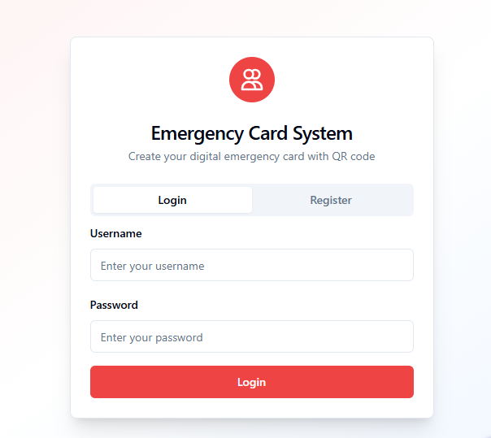
AI Tools you can use for Step 3-5:
ChatGPT/Perplexity AI: You can use these tools to compare your solutions and choose the most effective one
AI Tools you can use for the take-home task:
Canva AI/CoPilot AI/Meta AI: Use these mobile-based tools to generate images for the solution they want to design

Day 3: Prototype & Test
Step 6: Prototype – Building my first version
- What will my solution look like?
A web app where each user will have:
- A unique QR code
- Digital emergency card page containing:
- Name
- Age
- Blood group
- Emergency contacts
- Medical history
- Allergies
- Address
- Police & hospital quick call buttons

When the QR code is scanned:
- Emergency information opens instantly
- Rescuer can call emergency contacts
- Hospital details are shown
- First-aid instructions may appear
_________________________________________________________________________________
- What AI tools will I need to build this?
AI Tools I will use:
AI Tools I finally selected to build this solution:
- ChatGPT – For planning workflows & generating content
- Lovable AI – To build the website easily
- Canva AI – For card design
- QR Code Generator API
- Firebase / Airtable – For storing user data

What AI tools I finally selected to build this solution? [Eg: Claude AI, Grok AI, Chatling AI]
- ChatGPT – For backend logic & problem-solving
- Lovable AI – For designing the interface
- Canva – For QR card design
- Firebase – For maintaining emergency data
Step 7: Test – Getting Feedback
- Testers
- My classmates
- Community members
- Mentor
What feedback did I receive?
👍 What works well:
- Easy QR scan is fast
- Emergency details clearly visible
- Helpful for elderly & kids

🔧 What needs improvement:
- Add GPS location
- Add multi-language support
- Provide print option to use as wallet card

Take-home task
I recorded my project explanation and feedback as voice notes and uploaded them along with images and the website model on GitHub.
What I uploaded:
- Screenshots of QR card
- Website prototype
- Demo video
AI Tools used for Step 6–7:
- ChatGPT: Helped in testing the project and improving explanations for analytics results.
- Lovable AI: Used to build and refine the website structure.
- Canva AI: Used to design mock-ups and visuals for the project presentation.
- Figma AI: For creating interface wireframes and layout adjustments before development.

Day 4: Showcase
Step 8: Presenting my Innovation
- Final Project Title: Community Emergency QR Card System
- Document key points of my presentation:

Problem Statement:
People face delays in receiving emergency help due to lack of accessible medical details and emergency contacts. This can cost lives, especially in accidents, health issues, or when helping vulnerable individuals.

My Innovation:
A web-based QR emergency card that instantly shows:
- Personal details
- Photo
- Blood group
- Medical conditions
- Emergency contacts
- Allergies
- Hospital preference

Feedback I Received from Users:
- What works well:
✔ Simple design
✔ Instant access
✔ Accurate information display
- What can be improved:
– Add voice alert
– Allow offline storage
– Auto SMS alert option

Impact of My Innovation:
- The Saves valuable time during emergencies
- Helps rescuers & community members provide quick assistance
- Supports elderly, children, and accident victims
- Promotes digital safety in the community

Step 9: Reflections
- What did I enjoy the most?
I enjoyed designing the QR card and building a system that can actually save someone's life. The process of testing it on real users was exciting.
________________________________________________________________________________
- What was my biggest challenge?
Connecting the database with QR system and making the emergency card load instantly after scanning.

Take-home task
GITHUB: https://github.com/Pavithra1782005/Community-Emergency-QR-Card-System.git
PROJECT: https://mgx-5a1ir4ld3bo.mgx.world

